**A critique of the loanable funds approach**

By Servaas Storm

Dec 21, 2017 |



**Introduction**

Nine years after the Great Financial Crisis, U.S. output growth has not returned to its pre-recession trend, even after interest rates hit the ‘zero lower bound’ (ZLB) and the unconventional monetary policy arsenal of the Federal Reserve has been all but exhausted. It is widely feared that this insipid recovery reflects a ‘new normal’, characterized by “secular stagnation” which set in already well before the global banking crisis of 2008 (Summers 2013, 2015).

What are the causes of secular stagnation? What are the solutions to revive growth and get the U.S. economy out of the doldrums?

If we go by four of the [papers commissioned by the Institute for New Economic Thinking (INET) at its recent symposium](https://www.ineteconomics.org/events/secular-stagnation-new-york/agenda) to explore these questions, one headline conclusion stands out: the secular stagnation is caused by a heavy overdose of savings (relative to investment), which is caused by higher retirement savings due to declining population growth and an ageing labour force (Eggertson, Mehotra & Robbins 2017; Lu & Teulings 2017; Eggertson, Lancastre and Summers 2017), higher income inequality (Rachel & Smith 2017), and an inflow of  precautionary Asian savings (Rachel & Smith 2017). All these savings end up as deposits, or ‘loanable funds’ (LF), in commercial banks. In earlier times, so the argument goes, banks would successfully channel these ‘loanable funds’ into productive firm investment — by lowering the nominal interest rate and thus inducing additional demand for investment loans.

But this time is different: the glut in savings supply is  so large that banks cannot get rid of all the loanable funds even when they offer firms free loans—that is, even after they reduce the interest rate to zero, firms are not willing to borrow more in order to invest. The result is inadequate investment and a shortage of aggregate demand in the short run, which lead to long-term stagnation as long as the savings-investment imbalance persists. Summers (2015) regards a “chronic excess of saving over investment” as “the essence of secular stagnation”. Monetary policymakers at the Federal Reserve are in a fix, because they cannot lower the interest rate further as it is stuck at the ZLB. Hence, forces of demography and ageing, higher inequality and thrifty Chinese savers are putting the U.S. economy on a slow-moving turtle — and not much can be done, it seems, to halt the resulting secular stagnation.

This is clearly a depressing conclusion, but it is also wrong.

To see this, we have to understand why there is a misplaced focus on the market for loanable funds that ignores the role of fiscal policy that is plainly in front of us. In other words, we need to step back from the trees of dated models and see the whole forest of our economy.

**The Market for Loanable Funds**

In the papers mentioned, commercial banks must first mobilise savings in order to have the loanable funds (LF) to originate new (investment) loans or credit. Banks are therefore intermediaries between “savers” (those who provide the LF-supply) and “investors” (firms which demand the LF). Banks, in this narrative, do not create money themselves and hence cannot *pre*-finance investment by new money. They only move it between savers and investors.

We apparently live in a non-monetary (corn) economy—one that just exchanges a real good that everybody uses, like corn.  Savings (or LF-supply) are assumed to rise when the interest rate R goes up, whereas investment (or LF-demand) must decline when R increases. This is the stuff of textbooks, as is illustrated by Greg Mankiw’s (1997, p. 63) explanation:

“In fact, saving and investment can be interpreted in terms of supply an demand. In this case, the ‘good’ is loanable funds, and its ‘price’ is the interest rate. Saving is the supply of loans—individuals lend their savings to investors, or they deposit their saving in a bank that makes the loan for them. Investment is the demand for loanable funds—investors borrow from the public directly by selling bonds or indirectly by borrowing from banks. [….] At the equilibrium interest rate, saving equals investment and the supply of loans equals the demand.”

But the loanable funds market also forms the heart of complicated dynamic stochastic general equilibrium (DSGE) models, beloved by ‘freshwater’ and ‘saltwater’ economists alike (Woodford 2010), as should be clear from the commissioned INET papers as well. Figure 1 illustrates the loanable funds market in this scheme. The upward-sloping curve tells us that savings (or LF-supply) goes up as the interest rate R increases. The downward-sloping curve shows us that investment (or LF-demand) declines if the cost of capital (R) goes up. In the initial situation, the LF-market clears at a positive interest rate R0 > 0. Savings equal investment, which implies that LF-supply matches LF-demand, and in this—happy—equilibrium outcome, the economy can grow along some steady-state path.

To see how we can get secular stagnation in such a loanable-funds world, we introduce a shock, say, an ageing population (a demographic imbalance), a rise in (extreme) inequality, or an Asian savings glut, due to which the savings schedule shifts down. Equilibrium in the new situation should occur at R1 which is negative. But this can’t happen because of the ZLB: the nominal interest cannot decline below zero. Hence R is stuck at the ZLB and savings exceed investment, or LF-supply > LF-demand. This is a disequilibrium outcome which involves an over-supply of savings (relative to investment), in turn leading to depressed growth.

Ever since Knut Wicksell’s (1898) restatement of the doctrine, the loanable funds approach has exerted a surprisingly strong influence upon some of the best minds in the profession. Its appeal lies in the fact that it can be presented in digestible form in a simple diagram (as Figure 1), while its micro-economic logic matches the neoclassical belief in the ‘virtue of thrift’ and Max Weber’s Protestant Ethic, which emphasize austerity, savings (before spending!) and delayed gratification as the path to bliss.

The problem with this model is that it is wrong (see Lindner 2015; [Taylor 2016](https://www.ineteconomics.org/uploads/papers/Loanable_Funds_Macro_Models_Taylor_120316.pdf)). Wrong in its conceptualisation of banks (which are not just intermediaries pushing around existing money, but which can create new money *ex nihilo*), wrong in thinking that savings or LF-supply have anything to do with “loans” or “credit,” wrong because the empirical evidence in support of a “chronic excess of savings over investment” is weak or lacking, wrong in its utter neglect of finance, financialization and financial markets,  wrong in its assumption that the interest rate is some “market-clearing” price (the interest rate, as all central bankers will acknowledge, is the principal instrument of monetary policy), and wrong in the assumption that the two schedules—the LF-supply curve and the LF-demand curve—are independent of one another (they are not, as Keynes already pointed out).

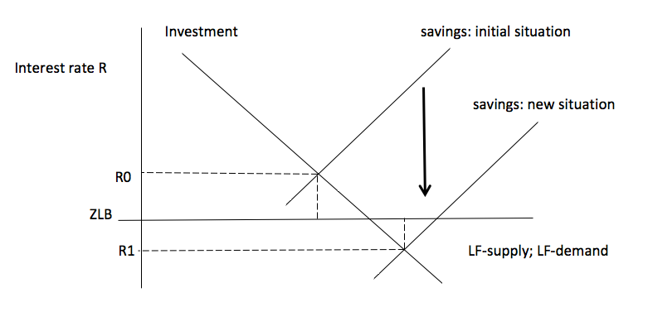

Figure 1: The Loanable Funds Market: A Savings Glut Causing Secular Stagnation

I wish to briefly elaborate these six points. I understand that each of these criticisms is known and I entertain little hope that that any of this will make people reconsider their approach, analysis, diagnosis and conclusions. Nevertheless, it is important that these criticisms are raised and not shoveled under the carpet. The problem of secular stagnation is simply too important to be left mis-diagnosed.

**First Problem: Loanable Funds Supply and Demand Are Not Independent Functions**

Let me start with the point that the LF-supply and LF-demand curve are not two independent schedules. Figure 1 presents savings and investment as functions of only the interest rate R, while keeping all other variables unchanged. The problem is that the *ceteris paribus* assumption does not hold in this case. The reason is that savings and investment are both affected by, and at the same time determined by, changes in income and (changes in) income distribution. To see how this works, let us assume that the average propensity to save rises in response to the demographic imbalance and ageing. As a result, consumption and aggregate demand go down. Rational firms, expecting future income to decline, will postpone or cancel planned investment projects and investment declines (due to the negative income effect and for a given interest rate R0). This means that LF-demand curve in Figure 1 must shift downward in response to the increased savings. The exact point was made by Keynes (1936, p. 179):

“The classical theory of the rate of interest [the loanable funds theory] seems to suppose that, if the demand curve for capital shifts or if the curve relating the rate of interest to the amounts saved out of a given income shifts or if both these curves shift, the new rate of interest will be given by the point of intersection of the new positions of the two curves. But this is a nonsense theory. For the assumption that income is constant is inconsistent with the assumption that these two curves can shift independently of one another. If either of them shift, then, in general, income will change; with the result that the whole schematism based on the assumption of a given income breaks down … In truth, the classical theory has not been alive to the relevance of changes in the level of income or to the possibility of the level of income being actually a function of the rate of the investment.”

Let me try to illustrate this using Figure 2. Suppose there is an exogenous (unexplained) rise in the average propensity to save. In reponse, the LF-supply curve shifts down, but because (expected) income declines, the LF-demand schedule shifts downward as well. The outcome could well be that there is no change in equilibrium savings and equilibrium investment. The only change is that the ‘natural’ interest is now R1 and equal to the ZLB. Figure 2 is, in fact, consistent with the empirical analysis (and their Figure of global savings and investment) of Rachel & Smith. Let me be clear: Figure 2 is not intended to suggest that the loanable funds market is useful and theoretically correct. The point I am trying to make is that income changes and autonomous demand changes are much bigger drivers of both investment and saving decisions than the interest rate. Market clearing happens here—as Keynes was arguing—because the level of economic activity and income adjust, not because of interest-rate adjustment.

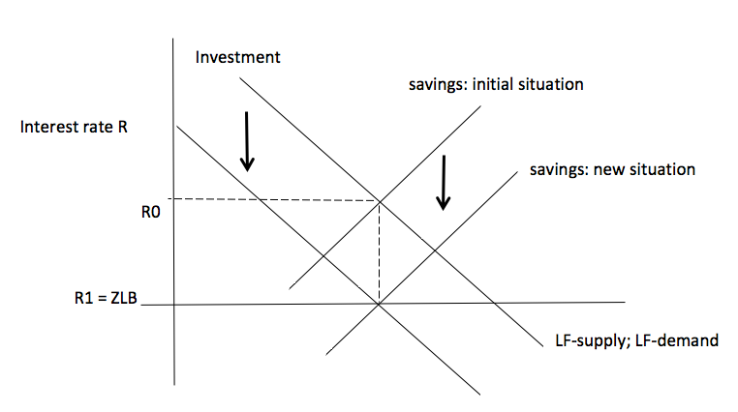

Figure 2: The Loanable Funds Market: Shifts in Both Schedules

**Second Problem: Savings Do Not Fund Investment, Credit Does…**

The loanable funds doctrine wrongly assumes that commercial bank lending is constrained by the prior availability of loanable funds or savings.  The simple point in response is that, in real life, modern banks are not just intermediaries between ‘savers’ and ‘investors’, pushing around already-existing money, but are money creating institutions. Banks create new money *ex nihilo*, i.e. without prior mobilisation of savings. This is illustrated by Werner’s (2014) case study of the money creation process by one individual commercial bank. What this means is that banks do *pre-finance* investment, as was noted by Schumpeter early on and later by Keynes (1939), Kaldor (1989), Kalecki, and numerous other economists.  It is for this reason that Joseph Schumpeter (1934, p. 74) called the money-creating banker ‘the ephor of the exchange economy’—someone who by creating credit (*ex nihilo*) is pre-financing new investments and innovation and enables “the carrying out of new combinations, authorizes people, in the name of society as it were, to form them.” Nicholas Kaldor (1989, p. 179) hit the nail on its head when he wrote that “[C]redit money has no ‘supply function’ in the production sense (since its costs of production are insignificant if not actually zero); it comes into existence as a result of bank lending and is extinguished through the repayment of bank loans. At any one time the volume of bank lending or its rate of expansion is limited only by the availability of credit-worthy borrowers.” Kaldor had earlier expressed his views on the endogeneity of money in his evidence to the Radcliffe Committee on the Workings of the Monetary System, whose report (1959) was strongly influenced by Kaldor’s argumentation.

Or take Lord Adair Turner (2016, pp. 57) to whom the loanable-funds approach is 98% fictional, as he writes:

“Read an undergraduate textbook of economics, or advanced academic papers on financial intermediation, and if they describe banks at all, it is usually as follows: “banks take deposits from households and lend money to businesses, allocating capital between alternative capital investment possibilities.” But as a description of what modern banks do, this account is largely fictional, and it fails to capture their essential role and implications. […] Banks create credit, money, and thus purchasing power. […]  The vast majority of what we count as “money’ in modern economies is created in this fashion: in the United Kingdom 98% of money takes this form ….”

We therefore don’t need savings to make possible investment—or, in contrast to the Protestant Ethic, banks allow us to have ‘gratification’ even if we have not been ‘thrifty’ and austere, as long as there are slack resources in the economy.

It is by no means a secret that commercial banks create new money. As the Bank of England (2007) writes, “When bank make loans they create additional deposits for those that have borrowed” (Berry *et al.* 2007, p. 377).  Or consider the following statement from the Deutsche Bundesbank (2009): “The commercial banks can create money themselves ….”  Across the board, central bank economists, including economists working at the Bank for International Settlements (Borio and Disyatat 2011), have rejected the loanable funds model as a wrong description of how the financial system actually works (see McLeay *et al*. 2014a, 2014b; Jakab and Kumhof 2015). And the Deutsche Bundesbank (2017) leaves no doubt as to how the banking system works and money is created in actually-existing capitalism, stating that the ability of banks to originate loans does not depend on the prior availability of saving deposits. Bank of England economists Zoltan Jakab and Michael Kumhoff (2015) reject the loanable-funds approach in favour of a model with money-creating banks. In their model (as in reality), banks pre-finance investment; investment creates incomes; people save out of their incomes; and at the end of the day, *ex-post* savings equal investment. This is what Jakab and Kumhoff (2015) conclude:

“…. if the loan is for physical investment purposes, this new lending and money is what triggers investment and therefore, by the national accounts identity of saving and investment (for closed economies), saving. Saving is therefore a consequence, not a cause, of such lending. Saving does not finance investment, financing does. To argue otherwise confuses the respective macroeconomic roles of resources (saving) and debt-based money (financing).”

Savings are a *consequence* of credit-financed investment (rather than a *prior* condition) — and we cannot draw a savings-investment cross as in Figure 1, *as if* the two curves are independent. They are not. There exists therefore no ‘loanable funds market’ in which scarce savings constrain (through interest rate adjustments) the demand for investment loans.

Highlighting the loanable funds fallacy, Keynes wrote in “The Process of Capital Formation” (1939):

“Increased investment will always be accompanied by increased saving, but it can never be preceded by it. Dishoarding and credit expansion provides not an alternative to increased saving, but a necessary preparation for it. It is the parent, not the twin, of increased saving.”

This makes it all the more remarkable that some of the authors of the commissioned conference papers continue to frame their analysis in terms of the discredited loanable funds market which wrongly assumes that savings have an existence of their own—separate from investment, the level of economic activity and the distribution of incomes.

**Third Problem: The Interest Rate Is a Monetary Policy Instrument, Not a Market-Clearing Price**

In loanable funds theory, the interest rate is a market price, determined by LF-supply and LF-demand (as in Figure 1). In reality, central bankers use the interest rate as their principal policy instrument (Storm and Naastepad 2012). It takes effort and a considerable amount of sophistry to match the loanable funds theory and the usage of the interest rate as a policy instrument. However, once one acknowledges the empirical fact that commercial banks create money *ex nihilo*, which means money supply is endogenous, the model of an interest-rate clearing loanable funds market becomes untenable.  Or as Bank of England economists Jakab and Kumhof (2015) argue:

“modern central banks target interest rates, and are committed to supplying as many reserves (and cash) as banks demand at that rate, in order to safeguard financial stability. The quantity of reserves is therefore a consequence, not a cause, of lending and money creation. This view concerning central bank reserves […] has been repeatedly described in publications of the world’s leading central banks.”

What this means is that the interest rate may well be at the ZLB, but this is not caused by a savings glut in the loanable funds market, but the result of a deliberate policy decision by the Federal Reserve—in an attempt to revive sluggish demand in a context of stagnation, subdued wage growth, weak or no inflation, substantial hidden un- and underemployment, and actual recorded unemployment being (much) higher than the NAIRU (see Storm and Naastepad 2012). Seen this way, the savings glut is the *symptom* (or *consequence*) of an aggregate demand shortage which has its roots in the permanent suppression of wage growth (relative to labour productivity growth), the falling share of wages in income, the rising inequalities of income and wealth (Taylor 2017) as well as the financialization of corporations (Lazonick 2017) and the economy as a whole (Storm 2018). It is not the cause of the secular stagnation—unlike in the loanable funds models.

**Fourth Problem: The Manifest Absence of Finance and Financial Markets**

What the various commissioned conference papers do not acknowledge is that the increase in savings (mostly due to heightened inequality and financialization) is not channeled into higher real-economy investment, but is actually channeled into more lucrative financial (derivative) markets. Big corporations like Alphabet, Facebook and Microsoft are holding enormous amounts of liquidity and IMF economists have documented the growth of global institutional cash pools, now worth $5 to 6 trillion and managed by asset or money managers in the shadow banking system (Pozsar 2011; Pozsar and Singh 2011; Pozsar 2015). Today’s global economy is suffering from an unprecedented “liquidity preference”—with the cash safely “parked” in short-term (over-collateralized lending deals in the repo-market. The liquidity is used to earn a quick buck in all kinds of OTC derivatives trading, including forex swaps, options and interest rate swaps. The global savings glut is the same thing as the global overabundance of liquidity (partying around in financial markets) and also the same thing as the global demand shortage—that is: the lack of investment in real economic activity, R&D and innovation.

The low interest rate is important in this context, because it has dramatically lowered the opportunity cost of holding cash—thus encouraging (financial) firms, the rentiers and the super-rich to hold on to their liquidity and make (quick and relatively safe and high) returns in financial markets and exotic financial instruments. Added to this, we have to acknowledge the fact that highly-leveraged firms are paying out most of their profits to shareholders as dividends or using it to buy back shares (Lazonick 2017). This has turned out to be damaging to real investment and innovation, and it has added further fuel to financialization (Epstein 2018; Storm 2018). If anything, firms have stopped using their savings (or retained profits) to finance their investments which are now financed by bank loans and higher leverage. If we acknowledge these roles of finance and financial markets, then we can begin to understand why investment is depressed and why there is an aggregate demand shortage. More than two decades of financial deregulation have created a rentiers’ delight, a capitalism without ‘compulsions’ on financial investors, banks, and the property-owning class which in practice has led to ‘capitalism for the 99%’ and ‘socialism for the 1%’ (Palma 2009; Epstein 2018) For authentic Keynesians, this financialized system is the exact opposite of Keynes’ advice to go for the euthanasia of the rentiers (*i.e.* design policies to reduce the excess liquidity).

**Fifth Problem: Confusing Savings with “Loans,”**

**or Stocks with Flows**

“I have found out what economics is,’ Michał Kalecki once told Joan Robinson, “it is the science of confusing stocks with flows.”

If anything, Kalecki’s comment applies to the loanable funds model. In the loanable fund universe, as Mankiw writes and as most commissioned conference papers argue, saving equals investment and the supply of loans equals the demand at some equilibrium interest rate. But savings and investment are *flow* variables, whereas the supply of loans and the demand for loans are *stock* variables. Simply equating these flows to the corresponding stocks is not considered good practice in stock-flow-consistent macro-economic modelling. It is incongruous, because even if we assume that the interest rate does clear “the stock of loan supply” and “the stock of loan demand”, there is no reason why the same interest rate would *simultaneously* balance savings (*i.e.* the increase in loan supply) and investment (*i.e.* the increase in loan demand). So what is the theoretical rationale of assuming that some interest rate is clearing the loanable funds market (which is defined in terms of *flows*)?

To illustrate the difference between stocks and flows: the stock of U.S. loans equals around 350% of U.S. GDP (if one includes debts of financial firms), while gross savings amount to 17% of U.S. GDP. Lance Taylor (2016) presents the basic macroeconomic flows and stocks for the U.S. economy to show how and why loanable funds macro models do not fit the data—by a big margin. No interest rate adjustment mechanism is strong enough to bring about this (ex-post) balance in terms of *flows*, because the interest rate determination is overwhelmed by changes in loan supply and demand *stocks*. What is more, and as stated before, we don’t actually use ‘savings’ to fund ‘investment’. Firms do not use retained profits (or corporate savings) to finance their investment, but in actual fact disgorge the cash to shareholders (Lazonick 2017). They finance their investment by bank loans (which is newly minted money).  Households use their (accumulated) savings to buy bonds in the secondary market or any other existing asset. In that case, the savings do not go to funding new investment — but are merely used to re-arrange the composition of the financial portfolio of the savers.

**Final Problem: The Evidence of a Chronic Excess of Savings Over Investment is Missing**

If Summers claims that there is a “chronic excess of savings over investment,” what he means is that ex-ante savings are larger than ex-ante investment. This is a difficult proposition to empirically falsify, because we only have ex-post (national accounting) data on savings and investment which presume the two variables are equal. However, what we can do is consider data on (global) gross and net savings rates (as a proportion of GDP) to see if the propensity to save has increased. This is what Bofinger and Ries (2017) did and they find that global saving rates of *private households* have declined dramatically since the 1980s. This means, they write, that one can rule out ‘excess savings’ due to demographic factors (as *per* Eggertson, Mehotra & Robbins 2017; Eggertsson, Lancastre & Summers 2017; Rachel & Smith 2017; and Lu & Teulings 2017). While the average saving propensity of household has declined, the aggregate propensity to save has basically stayed the same during the period 1985-2014. This is shown in Figure 3 (reproduced from Bofinger and Reis 2017) which plots the ratio of global gross savings (or global gross investment) to GDP against the world real interest rate during 1985-2014. A similar figure can be found in the paper by Rachel and Smith (2017). What can be seen is that while there has been no secular rise in the average global propensity to save, there has been a secular decline in interest rates. This drop in interest rates to the ZLB is not caused by a savings glut, nor by a financing glut, but is the outcome of the deliberate decisions of central banks to lower the policy rate in the face of stagnating economies, put on a ‘slow-moving turtle’ by a structural lack of aggregate demand which—as argued by Storm and Naastepad (2012) and Storm (2017)—is largely due to misconceived macro and labour-market policies centered on suppressing wage growth, fiscal austerity, and labour market deregulation.

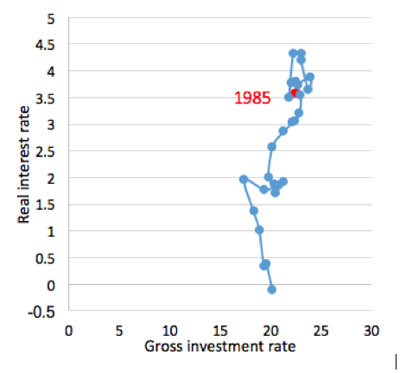

Saving/Investment Equilibria and World Real Interest Rate, 1985-2014

Source: Bofinger and Reis (2017), Figure 1(a).

To understand the mechanisms underlying Figure 3, let us consider Figure 4 which plots investment demand as a negative function of the interest rate. In the ‘old situation’, investment demand is high at a (relatively) high rate of interest (R0); this corresponds to the data points for the period 1985-1995 in Figure 3. But then misconceived macro and labour-market policies centered on suppressing wage growth, fiscal austerity, and labour market deregulation began to depress aggregate demand and investment—and as a result, the investment demand schedule starts to shift down and to become more steeply downward-sloping at the same time. In response to the growth slowdown (and weakening inflationary pressure), central banks reduce R—but without any success in raising the gross investment rate. This process continues until the interest rate hits the ZLB while investment has become practically interest-rate insensitive, as investment is now overwhelmingly determined by pessimistic profit expectations; this is indicated by the new investment schedule (in red). That the economy is now stuck at the ZLB is not caused by a “chronic excess of savings” but rather by a chronic shortage of aggregate demand—a shortage created by decades of wage growth moderation, labour market flexibilization, and heightened job insecurity as well as the financialization of corporations and the economy at large (Storm 2018).

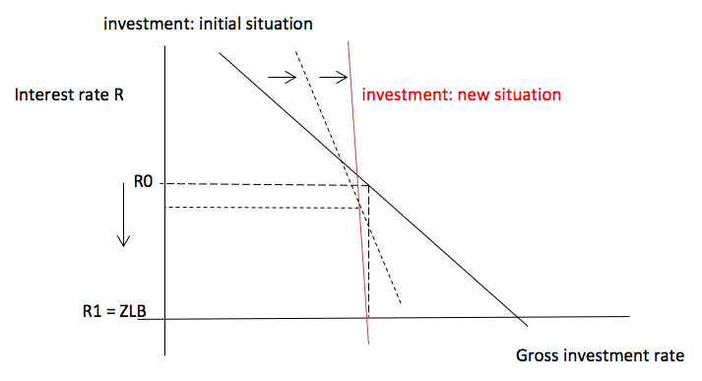

Figure 4: Secular Stagnation As a Crisis of Weak Investment Demand

**Conclusions**

The consensus in the literature and in the commissioned conference papers that the global decline in real interest rates is caused by a higher propensity to save, above all due to demographic reasons, is wrong in terms of underlying theory and evidence base.  The decline in interest rates is the monetary policy response to stalling investment and growth, both caused by a shortage of global demand. However, the low interest rates are unable to revive growth and halt the secular stagnation, because there is little reason for firms to expand productive capacity in the face of the persistent aggregate demand shortage. Unless we revive demand, for example through debt-financed fiscal stimulus or a drastic and permanent progressive redistribution of income and wealth in favour of lower-income groups (Taylor 2017), there is no escape from secular stagnation. The narrow focus on the ZLB and powerless monetary policy within the framing of a loanable-funds financial system blocks out serious macroeconomic policy debate on how to revive aggregate demand in a sustainable manner. It will keep the U.S. economy on the slow-moving turtle — not because policymakers cannot do anything about it, but we choose to do so. The economic, social and political damage, fully self-inflicted, is going to be of historic proportions.

It is not a secret that the loanable funds approach is fallacious (Lindner 2015; Taylor 2016; Jakab and Kumhof 2015). While academic economists continue to refine their Ptolemaic model of a loanable-funds market, central bank economists have moved on—and are now exploring the scope of and limitations to monetary policymaking in a monetary economy. Keynes famously wrote that “Practical men who believe themselves to be quite exempt from any intellectual influence, are usually the slaves of some defunct economist. Madmen in authority, who hear voices in the air, are distilling their frenzy from some academic scribbler of a few years back.”  In 2017, things seem to happen the other way around: academic economists who believe themselves to be free thinkers are caught in the stale theorizing of a century past. The puzzle is, as Lance Taylor (2016, p. 15) concludes “why [New Keynesian economists] revert to Wicksell on loanable funds and the natural rate while ignoring Keynes’s innovations. Maybe, as [Keynes] said in the preface to the General Theory, “‘The difficulty lies not in the new ideas, but in escaping from the old ones …..’ (p. viii)”

Due to our inability to free ourselves from the discredited loanable funds doctrine, we have lost the forest for the trees. We cannot see that the solution to the real problem underlying secular stagnation (a structural shortage of aggregate demand) is by no means difficult: use fiscal policy—a package of spending on infrastructure, green energy systems, public transportation and public services, and progressive income taxation—and raise (median) wages.

**References**

Bofinger, P. and M. Reis. 2017. ‘Excess saving and low interest rates: Assessing theory and evidence from the Global Crisis.’ VoxEU. Available at: <http://voxeu.org/article/excess-saving-and-low-interest-rates-theory-and-evidence>

Borio, C. and P. Disyatat. 2011. ‘Global imbalances and the financial crisis: link or no link?’ *BIS Working Paper* 346.

Committee on the Working of the Monetary System. 1959. Report; known as The Radcliffe Report.  London: HM Stationery Office.

Deutsche Bundesbank. 2009. Geld und Geldpolitik. As cited in J. Ryan-Collins, T. Greenham, R. Werner and A. Jackson (2011). *Where Does Money Come From? A Guide to the U.K. Monetary and Banking System*. London: New Economics Foundation.

Deutsche Bundesbank. 2017. ‘Die Rolle von Banken, Nichtbanken und Zentralbank im Geldschöpfungsprozess.’  Monatsbericht April. <http://www.bundesbank.de/Redaktion/DE/Downloads/Veroeffentlichungen/Monatsberichtsaufsaetze/2017/2017_04_geldschoepfungsprozess.pdf?__blob=publicationFile>

Eggertson, G.B.,  N.R. Mehotra and J.A. Robbins. 2017. ‘A model of secular stagnation: theory and quantitative evaluation’.

Eggertsson,  G.B., M. Lancastre and L.H. Summers. 2017. ‘Aging, output per capita and secular stagnation.’

Ferguson, T. and B. Page. 2017. “The hinge of fate? Economic and social populism in the 2016 Presidential elections. A preliminary analysis.” Paper Presented at the Institute for New Economic Thinking Conference, Edinburgh, October 2017.  Available at: <https://www.ineteconomics.org/research/research-papers/the-hinge-of-fate-economic-and-social-populism-in-the-2016-presidential-election-a-preliminary-exploration>

Jakab, Z. and M. Kumhof. 2015. ‘Banks are not intermediaries of loanable funds — and why this matters.’ *Working Paper No. 529*, London: Bank of England. <https://jrc.princeton.edu/sites/jrc/files/jakab-kumhof-boewp529.pdf>

Epstein, G. 2018. ‘On the social efficiency of finance.’ *Development and Change* 49 (2). Forthcoming.

Berry, S., R. Harrison, R. Thomas and I. de Weymarn. 2007. ‘Interpreting movements in Broad Money.’ *Bank of England Quarterly Bulletin* 2007-Q3.

Kaldor, N. 1989. *Further Essays on Economic Theory and Policy*. Edited by F. Targetti and A.P. Thirlwall. London: Duckworth.

Keynes, J.M. 1936. *The General Theory of Employment, Interest and Money*. London: Macmillan.

Keynes, J.M. 1937. ‘Alternative theories of the rate of interest.’ *The Economic Journal* 47 (186): 241–252.

Keynes, J.M. 1939. ‘The process of capital formation.’ *The Economic Journal* 49: 572-573.

Lazonick, W. 2017. ‘Innovative enterprise and sustainable prosperity.’ <https://www.ineteconomics.org/uploads/papers/Lazonick-Innovative-Enterprise-and-Sustainable-Prosperity-INET-20171010.pdf>

Lindner, F. 2015. ‘Does saving increase the supply of credit? A critique of loanable funds theory.’ *World Economic Review* 4: 1-26.

Lu, J. and C. Teulings. 2017. ‘Transition to slower population growth: demography and its effect on real interest rates.’

Mankiw, G.N. 1997. *Macroeconomics*, Third Edition. New York: Worth Publishers, 1997.

McLeay, M., A. Radia, and R. Thomas. 2014a. ‘Money creation in the modern economy.’ *Bank of England Quarterly Bulletin* 2014-Q1, pp. 14–27.

McLeay, M., A. Radia, and R. Thomas. 2014b. ‘Money in the modern economy: an introduction.’ *Bank of England Quarterly Bulletin* 2014-Q1, pp. 4–13.

Palma, J.G. 2009. ‘The revenge of the market on the rentiers. Why neo-liberal reports of the end of history turn out to be premature.’ *Cambridge Journal of Economics* 33(4), pp. 829–69.

Pozsar, Z., 2011. Institutional cash pools and the Triffin dilemma of the US banking system. *Financial Markets, Institutions & Instruments*  22(5), pp.283-318.

Pozsar, Z. and M. Singh. 2011. ‘The nonbank-bank nexus and the shadow banking system.’ *IMF Working Paper WP/11/289*. Washington, DC: IMF.

Pozsar, Z. 2015. ‘A macro view of shadow banking: levered betas and wholesale funding in the context of secular stagnation.’ INET Working paper. Available at SSRN: <https://ssrn.com/abstract=2558945>  or [http://dx.doi.org/10.2139/ssrn.2558945](https://dx.doi.org/10.2139/ssrn.2558945)

Rachel, L. and T.D. Smith. 2017. ‘Are low real interest rates here to stay?’

Storm, S. 2017. ‘The new normal: demand, secular stagnation and the vanishing middle class.’ *INET Working Paper* 55. <https://www.ineteconomics.org/uploads/papers/WP_55-Storm-The-New-Normal.pdf>

Storm, S. 2018. ‘Financialisation and economic development: an introduction to the debate on the social efficiency of modern finance.’ *Development and Change* 49 (2). Forthcoming.

Storm, S. and C.W.M. Naastepad. 2012. *Macroeconomics beyond the NAIRU*. Cambridge, Mass.: Harvard University Press.

Summers, L. 2013. Speech at the IMF Economic Forum, 14th Annual IMF Research Conference: Crises Yesterday and Today, Nov. 8, 2013:

Summers, L. 2015. ‘Demand side secular stagnation.’ *American Economic Review: Papers & Proceedings* 105 (5): 60-65.

Taylor, L. 2016. ‘The “Natural” Interest Rate and Secular Stagnation: Loanable Funds Macro Models Don’t Fit the Data” Schwartz Center for Economic Policy Analysis and Department of Economics, *The New School for Social Research, Working Paper Series 2016-6*. <http://www.economicpolicyresearch.org/images/docs/research/economic_growth/2016-6_Loanable_Funds_Macro_Models.pdf>

Taylor, L. 2017. ‘Why stopping tax reform won’t stop inequality.’ INET blogpost. Available at: <https://www.ineteconomics.org/perspectives/blog/why-stopping-tax-reform-wont-stop-inequality>

Temin, P. 2017. *The Vanishing Middle Class. Prejudice and Power in a Dual Economy*. Cambridge, Mass.: The MIT Press.

Turner, A. 2016. *Between Debt and the Devil. Money, credit, and Fixing Global Finance*. Princeton: Princeton University Press.

Werner, R.A. 2014. ‘Can banks individually create money out of nothing? The theories and the empirical evidence.’ *International Review of Financial Analysis* 36: 1–19.

Wicksell, K. 1898. *Geldzins und Güterpreise. Eine Studie über die den Tauschwert des Geldes bestimmenden Ursachen*. Jena: Gustav Fischer Verlag.

Woodford, M. 2010.  ‘Financial intermediation and macroeconomic analysis.’ *Journal of Economic Perspectives* 24 (4), pp. 21–44.